EASTERN INTERNATIONAL UNIVERSITY  SCHOOL OF COMPUTING AND INFORMATION TECHNOLOGY | Practice Assignment – Quarter …, 20…-20…  Course Name: Special Topic 1  Course Code: CSE 484  Student’s Full Name: Hà Quang Minh  Student ID: 1931220012
Lab 7

Background
This 4-hour lab applies Ansible for network automation on Cisco IOS-XE (CSR1000v). You will: install Ansible and the network collections, prepare an inventory, run playbooks using ios_command/ios_config, use conditions/loops/templates, and follow better practices (backups, vault, lint). Topics mirror the chapter slides: overview/architecture, inventory, conditions, loops, templates, and recommended practices.

Required Resources:
- 1 PC (Linux/macOS/WSL recommended), Python 3.10+, VS Code
- A reachable IOS-XE device (CSR1000v) with SSH/eAPI enabled
- Internet access to install: ansible, ansible-pylibssh, ansible-lint
- Ansible collections: cisco.ios, ansible.netcommon
- Credentials with privilege 15 (exec + enable)
Problem:

Part 1 —Install & Verify
Goal: a working Ansible environment that can “talk” to your CSR.

Create venv & install Ansible + libssh (agentless, Python-based):
python -m venv .venv && source .venv/bin/activate
pip install --upgrade pip
pip install ansible ansible-pylibssh ansible-lint
ansible --version

Install required collections (vendor modules live in collections):
ansible-galaxy collection install cisco.ios ansible.netcommon

Prepare working dir:
ansible-netlab/
├── ansible.cfg
├── inventories/
│ ├── hosts # INI
│ └── host_vars/
│ └── csr1.yml # per-device vars (YAML)
└── playbooks/
└── sanity.yml

Create ansible.cfg (enable libssh & safe defaults)
[defaults]
inventory = inventories/hosts
host_key_checking = False
stdout_callback = yaml
gathering = explicit
timeout = 30
retry_files_enabled = False

[persistent_connection]
connect_timeout = 30
command_timeout = 60

Inventory (inventories/hosts) using groups:
[ios]
csr1 ansible_host=192.168.2.50

Host vars (inventories/host_vars/csr1.yml):
ansible_user: cisco
ansible_password: cisco
ansible_become: true
ansible_become_method: enable
ansible_become_password: cisco

# Connection & OS
ansible_network_os: cisco.ios.ios
ansible_connection: ansible.netcommon.network_cli

# Optional: use libssh transport (recommended in chapter)
# ansible_network_cli_ssh_type: libssh

Sanity play (playbooks/sanity.yml) – gather facts and run a show:
- name: Sanity check IOS reachability
hosts: ios
gather_facts: no
tasks:
- name: Facts via ios_facts
cisco.ios.ios_facts:
- name: Show version
cisco.ios.ios_command:
commands: ["show version"]
register: showver
- name: Print model & version
debug:
msg: "Model={{ ansible_net_model }} Version={{ ansible_net_version }}"

Run it:
ansible-playbook playbooks/sanity.yml
Evidence: screenshot of successful run (facts & show version echoed). (Ansible overview/architecture, agentless, inventory basics.)

Self-Done Tasks
Break something intentionally (wrong password or wrong port), run the playbook, and capture the error message. Write a short explanation: What type of Ansible connection error was it?
My Solution
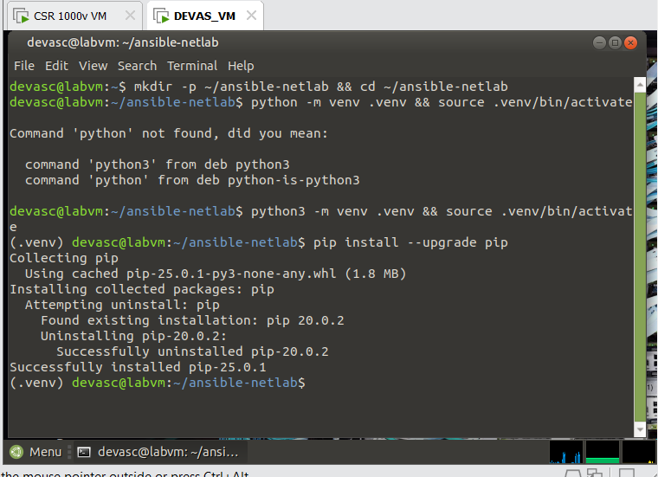
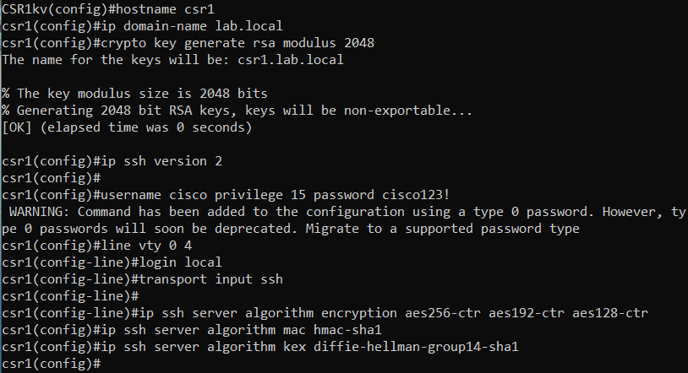
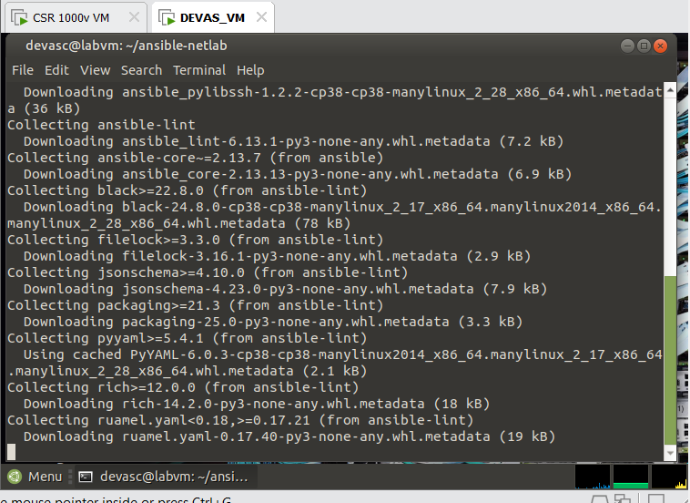
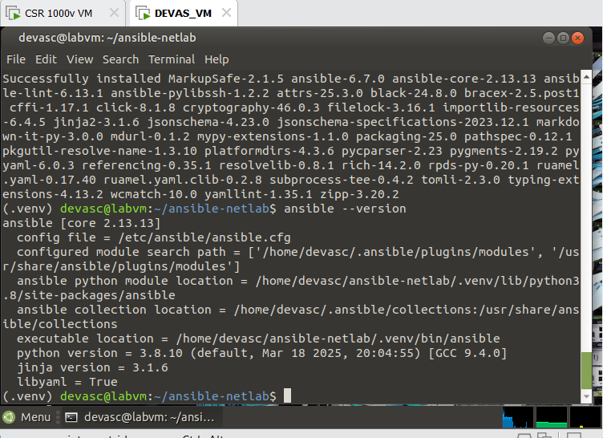
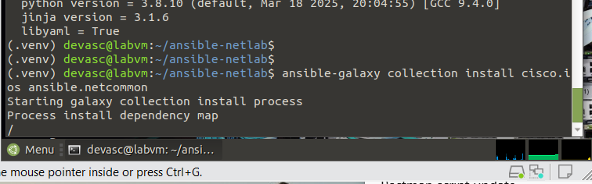
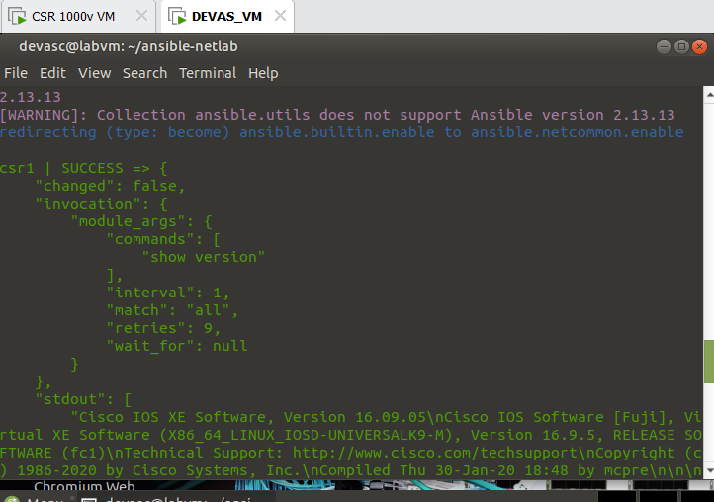
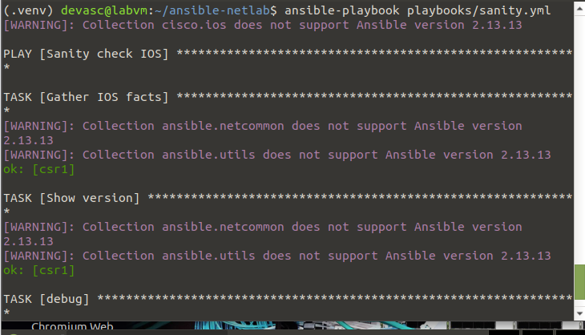
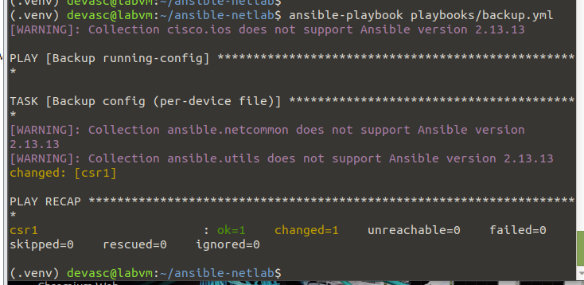
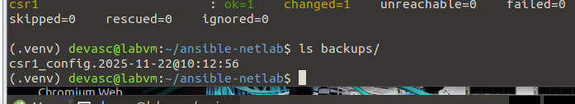

Part 2 — Backups & Idempotent Config (0:30–1:20)
Goal: use ios_config to back up and make safe changes (idempotence).

Backup play (playbooks/backup.yml) — automatic timestamped files:
- name: Backup running-config
hosts: ios
gather_facts: no
tasks:
- name: Backup config (per-device file)
cisco.ios.ios_config:
backup: true
backup_options:
dir_path: backups

Run: ansible-playbook playbooks/backup.yml

Idempotent config (playbooks/base_config.yml) — no repeated changes:
Idempotent config (playbooks/base_config.yml) — no repeated changes:
- name: Base hardening (idempotent)
hosts: ios
gather_facts: no
tasks:
- name: Global settings
cisco.ios.ios_config:
lines:
- service timestamps debug datetime msec
- service timestamps log datetime msec
- logging buffered 19999
- ip ssh version 2
- name: VTY lines (ensure SSH only)
cisco.ios.ios_config:
lines:
- exec-timeout 10 0
- transport input ssh
- login local
parents: line vty 0 4
Run twice and confirm no changes on second run (idempotence).
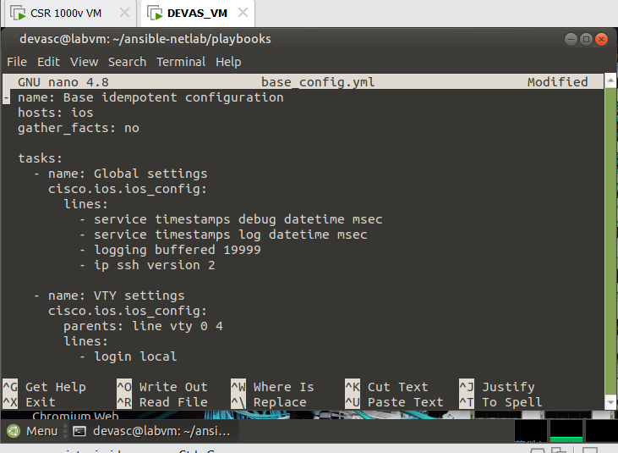
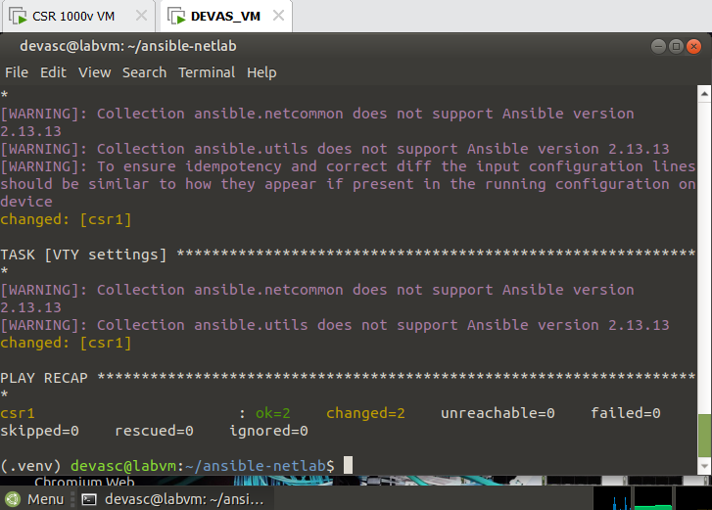

Self-Done Tasks
- Create a second backup play that only backs up configuration if the device hostname contains “LAB”:
  - Must use: when: "LAB" in ansible_net_hostname
Evidence: backup files under backups/, two run summaries (first “changed”, second “ok”).

Part 3 — Conditions & Facts
Goal: use when with network facts to gate changes.

Facts + conditional config (playbooks/cond.yml):
- name: Conditional hostname suffix
hosts: ios
gather_facts: no
tasks:
- name: Gather facts
cisco.ios.ios_facts:

- name: Append -LAB to hostname if not present
cisco.ios.ios_config:
lines:
- "hostname {{ ansible_net_hostname }}-LAB"
when: ansible_net_hostname is defined and
not ansible_net_hostname.endswith('-LAB')

- name: Show final hostname
cisco.ios.ios_command:
commands: ["show run | include ^hostname"]
register: h
- debug: var=h.stdout_lines

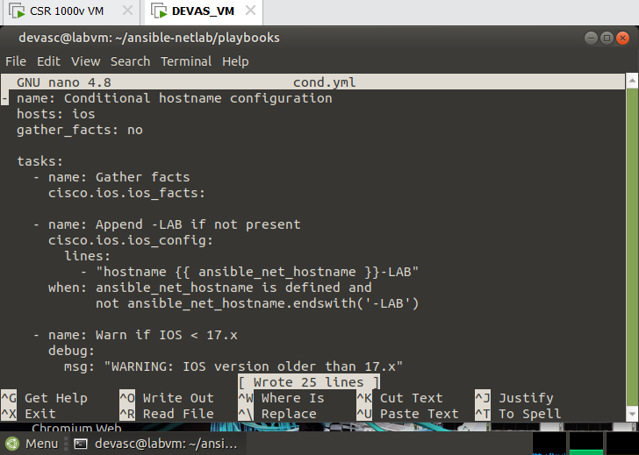
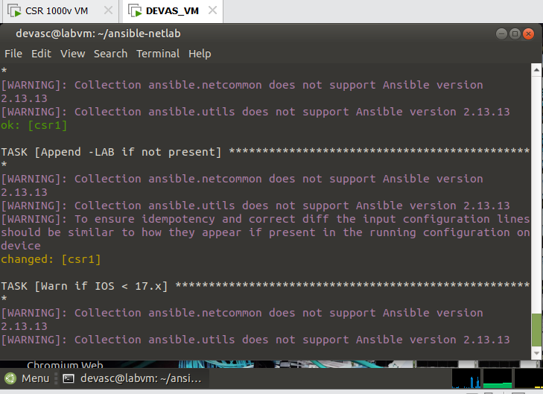
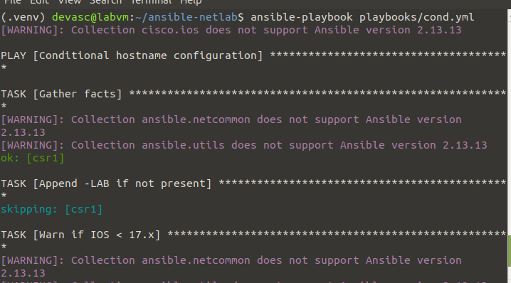

Explain (2–3 sentences):
How when prevents repeated/unsafe changes?
Evidence: play output demonstrating skipped when already compliant.

Self-Done Tasks
- Add a conditional task:
- If the device version is lower than 17.x, print a warning using a debug: task.
- Create a task that is executed only when:
- Interface Gi1 is administratively up (facts required).Use:
when: ansible_net_interfaces['GigabitEthernet1'].enabled

Part 4 — Loops (standard & dictionary)
Goal: configure multiple items cleanly using loops.

Standard loop to create VLANs (playbooks/vlans.yml):
- name: Create VLANs via loop
hosts: ios
gather_facts: no
vars:
vlans: [ {id: 10, name: APP}, {id: 20, name: DB}, {id: 30, name: WEB} ]
tasks:
- name: Ensure VLANs exist
cisco.ios.ios_config:
lines:
- "vlan {{ item.id }}"
- " name {{ item.name }}"
loop: "{{ vlans }}"
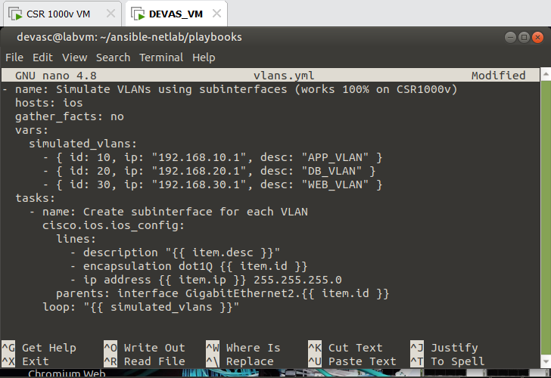

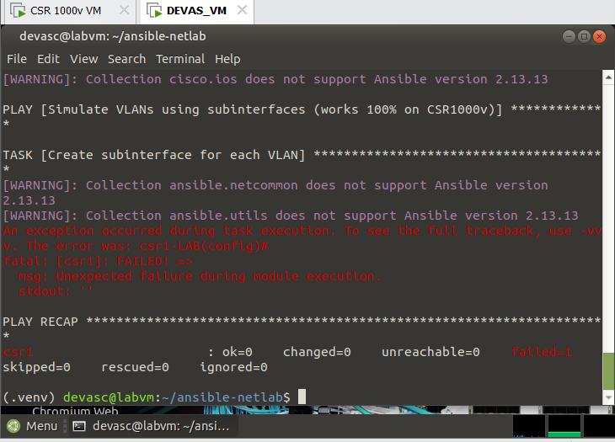

Dictionary loop for interfaces (playbooks/intfs.yml)
- name: Access ports via dict loop
hosts: ios
gather_facts: no
vars:
access_ports:
- { name: GigabitEthernet1, vlan: 10, desc: "APP Uplink" }
- { name: GigabitEthernet2, vlan: 20, desc: "DB Uplink" }
tasks:
- name: Configure access interface
cisco.ios.ios_config:
parents: "interface {{ item.name }}"
lines:
- "description {{ item.desc }}"
- "switchport mode access"
- "switchport access vlan {{ item.vlan }}"
- "no shutdown"
loop: "{{ access_ports }}"
Evidence: play recaps showing looped changes; show vlan brief and show run interface outputs.
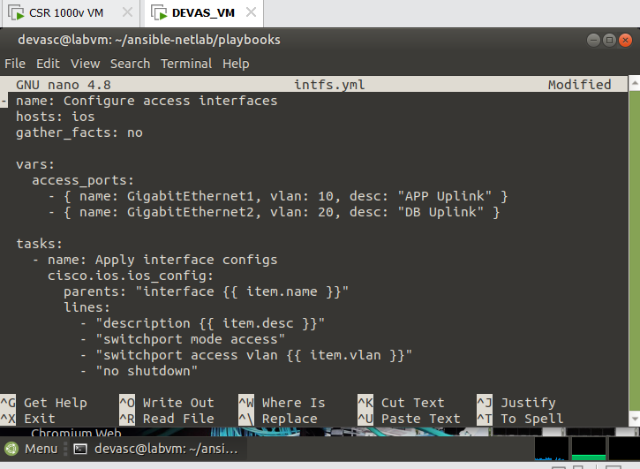
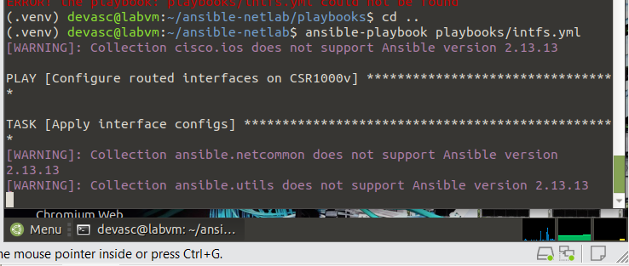
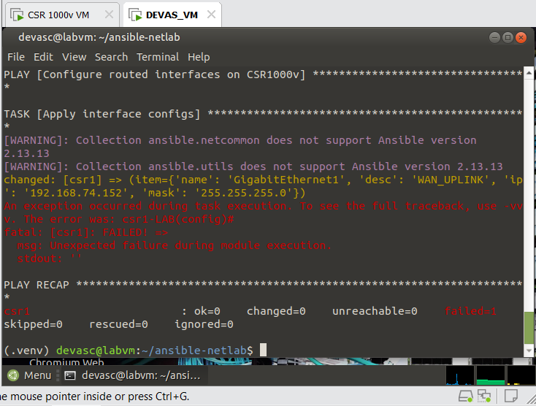

Submission: Must include:
- a pdf report file containing your information (student id, name), and images of the diagrams, codes, answers, evident,…
- and all source code files (if any)
in a zipped (.zip or *.rar) file to Moodle

